Digital Technologies & Hangarau Matihiko 3.8

Level 3, Credits 6, Assessment Internal

# Introduction

This assessment activity requires you to plan, develop and create a digital technologies outcome.

You will be assessed on

* how effectively you use project management tools and techniques to plan and manage the development of a digital outcome
* how effectively you decompose the problem into smaller components, and test and refine your media outcome so that it is a high-quality response to the task
* how well you have addressed relevant implications
* how well you synthesise information from the planning, testing and trialling of components to develop a high-quality response to the task (e.g. well-structured, logical, flexible, robust and comprehensively tested program)
* discuss how this information assisted in the development of a high-quality outcome

# Problem Statement

* Write your chosen problem statement here. If you are choosing an option from the website, copy-paste it here.

## Option 2: Find the Treasure

Teach an educational topic of your choice by developing a graphical adventure game.

Unlike option 1, which is a straight-forward quiz, you must create a scenario for this — adventuring to best a monster, solving a mystery, escaping from a dungeon, etc.

### Requirements

1. the game must include a 10x10 grid (or larger) to walk around
   * the grid tiles could represent locations
   * certain tiles could contain items/dangers
2. each turn, the user should be able to move a tile and/or perform an action at that tile
3. the game must include a stamina system
   * every few actions that the user takes should deplete the user’s stamina
   * specific actions and/or items can replenish the user’s stamina
   * if the user runs out of stamina, the game is over
4. the game must have a well-defined victory condition
   * what must happen for the game to be “won”?
   * what steps must occur for this to happen?
   * what could go wrong for the player?
5. how you integrate the educational topic into the game is up to you, but it must be present and directly lead to the victory condition
   * for example, deciphering a clue could lead to the correct place on the map to find the next clue, and so on
   * if you are unsure, consult with your teacher

# Decomposing the outcome

### Decomposing the digital technologies outcome into smaller components

* Decompose your digital technologies outcome into smaller components and rank the priority of each component.

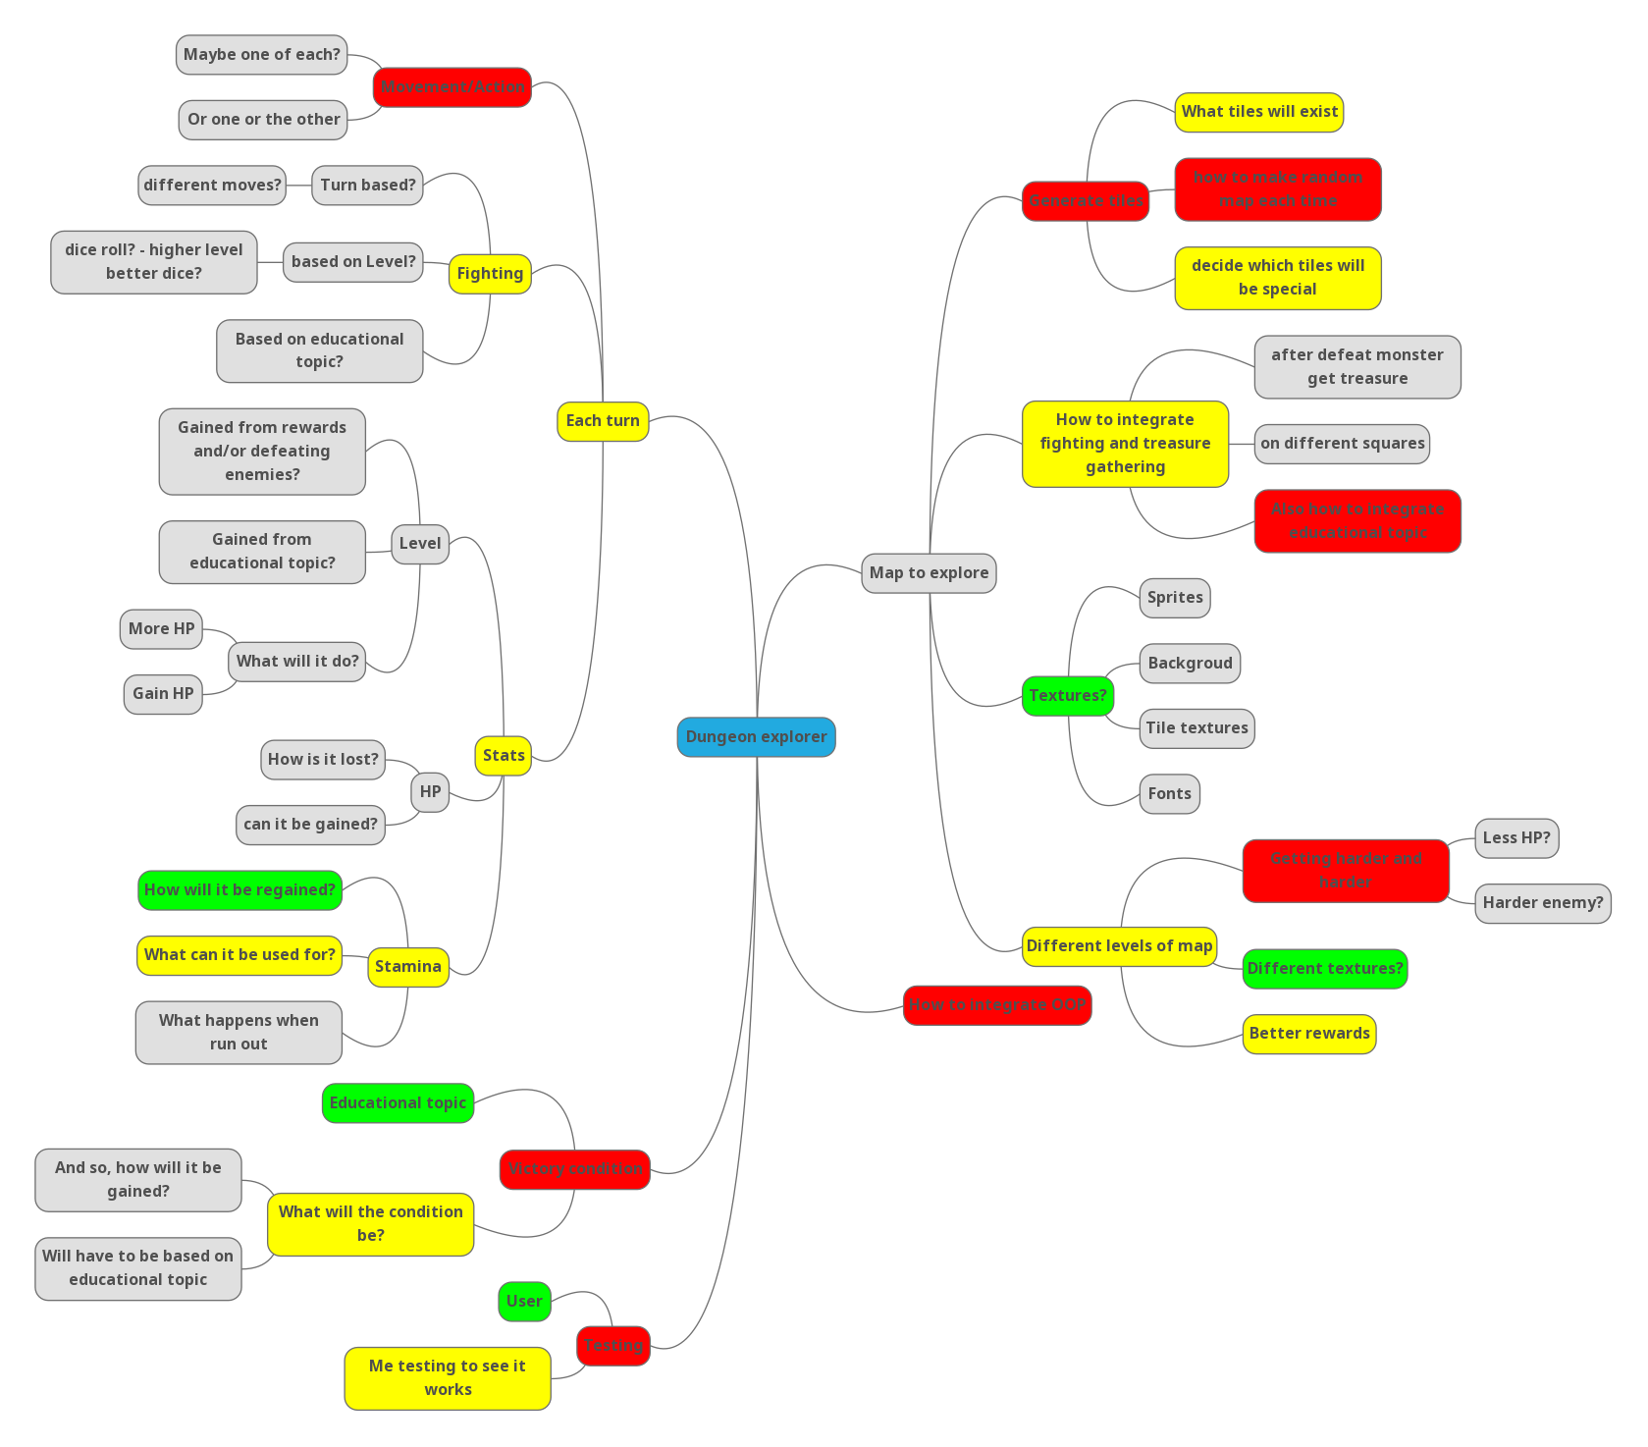

# Relevant Implications

### Addressing relevant implications

* *What relevant implications do you need to consider in the development of your outcome? Describe which you will address in its development.*

*Examples of relevant implications include:*

|  |  |  |  |  |  |
| --- | --- | --- | --- | --- | --- |
| *Social* | *Cultural* | *Legal* | *Ethical* | *Intellectual property* | *Accessibility* |
| *Usability* | *Functionality* | *Aesthetics* | *Sustainability & future-proofing* | *End-user requirements* | *Health & safety* |

### Implication #1: Intellectual Property

According to [google](https://languages.oup.com/google-dictionary-en/), intellectual property is “Intangible property that is the result of creativity, such as patents, copyrights, etc.”. This means that I will not be able to use such properties that I do not have direct approval from the owner to use in my project. Specifically, this means that ideas, images, and code that others have made, I will not be able to use in my project, like sprites, textures, specific game mechanics from individual games, and algorithms and code snippets from the internet.In order to address this relevant implication, I will either get my images from open source places, using the advanced google images filter, or make my own. I will get ideas for the game from my own brain, and from open source games. Lastly, I will get my code snippets from open source places like stack overflow, and Wikipedia, and the like.

### Implication #2: Aesthetics

The relevant implication aesthetics, according to [interaction-design.org](https://www.interaction-design.org/literature/topics/aesthetics), means “a core design principle that defines a design’s pleasing qualities”. This means that I will have to make my program aesthetically pleasing for the user, as otherwise, they will most likely not want to play the game, and so, why make it? It would be a pointless project. In order to address this implication, I will get user feedback on the sprites, backgrounds and themes, to see what they think looks the best, as they will know what looks the best for them, and implement that feedback to the best of my ability.

### Implication #2: Usability

[interaction-design.org](https://www.interaction-design.org/literature/topics/usability) states that “Usability is a measure of how well a specific user in a specific context can use a product/design to achieve a defined goal effectively, efficiently and satisfactorily”. This means that my project will need to be easy and intuitive to use, but also efficient for more experienced users who know what they are doing more. In order to address the implication of usability, I will get user feedback to see if it is intuitive and easy to use, and will incorporate shortcuts, such as key binds, to make it more efficient to user for experienced users, I will get feedback on and for those shortcuts also.

# Sprint #1

### Using recognised and appropriate project management tools and techniques to plan the development of a digital technologies outcome

## Planning

* When did this sprint start, and when is it projected to end?

**START DATE** Monday 1st August 2022

**FINISH DATE** Sunday 14th August 2022

* What components will work on during this sprint?

The bare bones of the game, how everything works on a basic level, apart from fighting as that could be a very big thing to work on

* Provide evidence (screenshot / photo) of your project management tool(s) being used to plan the development of your outcome at the beginning of your sprint here

Screenshot here

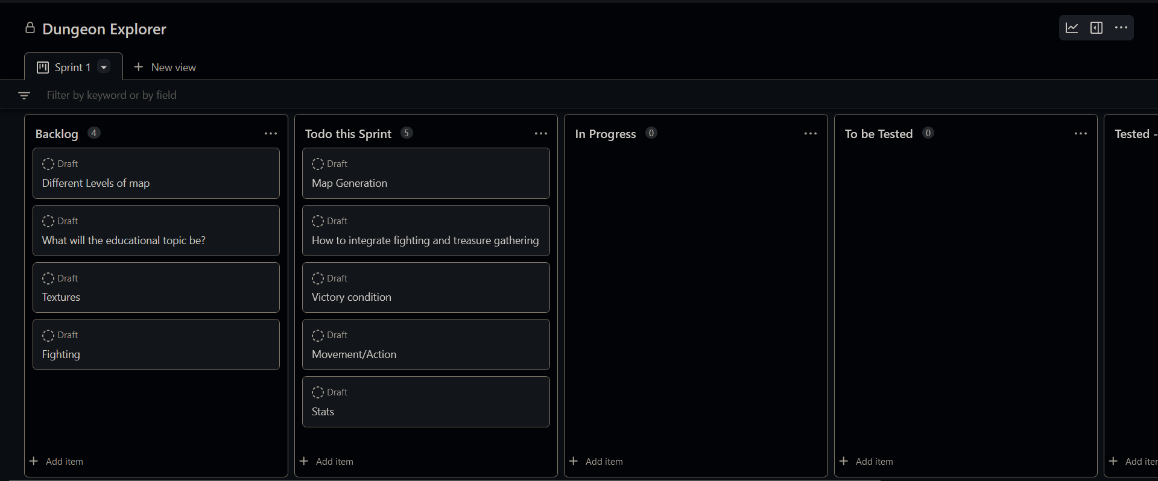

## Development

* What component(s) will you to trial?

The Mechanics of fighting and treasure gathering.

Victory condition

* Provide evidence of the option for each component you are going to trial, such as screenshots or explanations

### Component 1 – The mechanics of fighting and treasure gathering

|  |  |
| --- | --- |
| Option 1 | After fighting, user gains exp towards their level, and some money to spend at shops  Treasure chests and shops contain answers to questions of the educational topic and stats benefits |
| Option 2 | **No money, after fighting, user gains answers to questions of educational topic and stats benefits**  **Treasure chests contain mystery prizes – question answers, stats boosts, stats negatives (traps)** |
| Option 3 | **Fighting is completely separate, the only purpose is to get to rewards on the other side**  **Treasure chests contain money, or question answers**  **Shops give stats boosts**  **Traps are separate tiles, (invisible?)** |

### Component 2 – Victory condition

|  |  |
| --- | --- |
| Option 1 | At the end of each level, there is a quiz on everything taught so far, have to get above 80% to continue, harder levels, need more percentage. |
| Option 2 | **There are question tiles, on questions taught so far, each tile asks 1 (2?) questions, each question you get wrong counts against you, and you have to get below a certain number wrong to get to the next level (providing you don’t die)** |
| Option 3 | **No end of level requirement, have quiz tiles (5 questions) and question tiles (1 question), when they die, they get a score based on how many questions they got right, and how many they got wrong.** |

## Feedback

**Remember, for any component you trial, you should receive multiple feedback for it.  
Don’t get JUST one feedback per trialled component!**

**Component trialled** 1 & 2

**Feedback giver** Sophia **Date trialled** 3/08/2022

Option 1 for component #1 is best

Option 2 for component #2 is best, but should also have an end quiz

**Component trialled** 1 & 2

**Feedback giver** Ryan Gordon **Date trialled** 4/08/2022

For component 1, option 3 doesn't agree with me, I feel like you should definitely get some sort of reward after fighting. I like the way you gain xp after fighting in option 1, but considering the brief, I really like the way you gain answers to questions as a reward for fighting (so option 2). Maybe you could make yours enemies coding bugs that you need to defeat (just a suggestion). In terms of the chests and traps, I like the way option 2 does them, but also quite like the idea of having traps as separate tiles. Overall, option 2 is my favourite.

For component 2, I like the way option 2 does it. I feel like definitely not option 3.

**Component trialled** 1 & 2

**Feedback giver** Benjamin Smith **Date trialled** 4/08/2022

In terms of the requirements of the task, the stamina could be health - you lose health by answering questions incorrectly. This would mean options 2 or 3 for the victory condition would be better - they allow for the idea of depleting health. For the fighting mechanics, option 1 seems the most familiar, as it matches how most games that involve some kind of fighting work. Option 3 is a bit confusing - how is fighting 'completely separate', and what is 'the other side'? Option 1 also gives the user more freedom - they can try and answer questions without ever having looked at the answer, in order to save money for other things. For the victory condition, I do like the idea of a quiz at the end of a level, as it seems reminiscent of a 'boss fight' or something like that, but something like Dicey Dungeons, where there isn't a boss fight at the end of each level, could also work.

**Component trialled** 1 & 2

**Feedback giver** James Richards **Date trialled** 5/08/2022

For component one, option one is better , but they should get fun fact upon going down a level (loading screen?)

For component two, option one is better, but also have question tiles that don't count towards a score, but provide an advantage if they get it right, and a disadvantage if they get it wrong

**Component trialled** 1 & 2

**Feedback giver** Alan Teesdale **Date trialled** 5/08/2022

comp1 option 1, although I would imagine combat would be them quizzing you, and you take damage when you lose and deal damage when you get it correct

comp2 option 4 where you fight a boss that asks more difficult questions/pulls from the questions you got wrong

* What decision have you made based on this feedback? Explain:
* whether or not you will choose the most highly rated option, and why
* what changes you will incorporate, and why
* what suggestions you will not incorporate, and why

**Component One:**

Option one is the most highly rated option, with 4/5 people saying that this is the option that they prefer, so this is the option that I will implement into the program. I will add extra changes based on the feedback from Ryan Gordon, these include, the option to choose whether they want an answer or coins as a reward for fighting (they will always get exp), and as before, shops will be guaranteed prizes, such as stat boosts and answers, but treasure chests will be mystery boxes (like in option two). I will also add trap tiles that will be invisible, I will add these because I agree with the statements the Ryan has made, and these changes do not go against any of the other feedback I have received for this component. I will hold off on James’ idea of them getting a fun fact upon finishing a level because I do not know yet whether it will make the game too easy, though if getting answers becomes too hard, I will probably implement this.

**Component Two:**

I will combine all of my feedback together for this one, and not choose a single option that I provided, this is because of the differences between the pieces of feedback that I have received. I will have an end of level quiz, that will have questions, the answers of which have been available at some point during the players run, each incorrect answer will deplete the user’s health, and running out of health will end the run. I will also have question tiles that will have questions that may or may not have been provided answers yet, answering these will get you an advantage if you get it right, or disadvantage if you get it wrong. I can give the scenario of the quiz in the form of a boss fight, as it really makes no difference to the gameplay, just makes it slightly more gamey.

## Testing

* What components are you testing?

Type here

|  |  |  |  |  |  |
| --- | --- | --- | --- | --- | --- |
| **Type of test (E, B, I)** | **Method to Test** | **Value(s) to enter** | **Expected result** | **Actual result (screen snip / time stamp)** | **Comments/ changes needed** |
|  |  |  |  |  | Works as expected |
|  |  |  | Should show walls and some of the white squares will be replaced by other emojis representing different tile types |  | Something did not work  I found the problem, I didn’t actually call the function. |
|  |  |  |  |  | Well, at least it is calling the function now. |
|  |  |  |  |  | Oh, right, random.shuffle returns none and shuffles tiles in place |
|  |  |  |  |  | Yes, but I’m not sure why the emojies are not there |
|  |  |  |  |  | Nice, but it seems to be replacing walls with special tiles, and not the white tiles, also, there is no start? |
|  |  |  |  |  | Works as expected |
|  |  |  |  |  |  |

## Evaluation

* What components did you complete in this sprint? How do you know they are completed?

Type here

* What components’ development will carry on into the next sprint? Why?

Type here

* Provide evidence (screenshot) of your version control

Screenshot here

* Provide evidence (screenshot / photo) of your project management tool(s) being used to manage the development of your outcome at the end of your sprint here

Screenshot here

# Sprint #2

### Using recognised and appropriate project management tools and techniques to plan the development of a digital technologies outcome

## Planning

* When did this sprint start, and when is it projected to end?

**START DATE** START DATE HERE

**FINISH DATE** FINISH DATE HERE

* What components will work on during this sprint?

Type here

* Provide evidence (screenshot / photo) of your project management tool(s) being used to plan the development of your outcome at the beginning of your sprint here

Screenshot here

## Development

* What component(s) will you to trial?

Type here

* Provide evidence of the option for each component you are going to trial, such as screenshots or explanations

### Component 1

|  |  |
| --- | --- |
| Option 1 |  |
| Option 2 |  |
| Option 3 |  |

### Component 2 (If you are only trialling one component this sprint, delete this table)

|  |  |
| --- | --- |
| Option 1 |  |
| Option 2 |  |
| Option 3 |  |

## Feedback

**Remember, for any component you trial, you should receive multiple feedback for it.  
Don’t get JUST one feedback per trialled component!**

**Component trialled** COMPONENT HERE

**Feedback giver** NAME HERE **Date trialled** DATE HERE

Type feedback here

**Component trialled** COMPONENT HERE

**Feedback giver** NAME HERE **Date trialled** DATE HERE

Type feedback here

**Component trialled** COMPONENT HERE

**Feedback giver** NAME HERE **Date trialled** DATE HERE

Type feedback here

* What decision have you made based on this feedback? Explain:
* *whether or not you will choose the most highly rated option, and why*
* *what changes you will incorporate, and why*
* *what suggestions you will* ***not*** *incorporate, and why*

Type here

## Testing

* What components are you testing?

Type here

|  |  |  |  |  |  |
| --- | --- | --- | --- | --- | --- |
| **Type of test (E, B, I)** | **Method to Test** | **Value(s) to enter** | **Expected result** | **Actual result (screen snip / time stamp)** | **Comments/ changes needed** |
|  |  |  |  |  |  |
|  |  |  |  |  |  |
|  |  |  |  |  |  |
|  |  |  |  |  |  |
|  |  |  |  |  |  |
|  |  |  |  |  |  |
|  |  |  |  |  |  |
|  |  |  |  |  |  |

## Evaluation

* What components did you complete in this sprint? How do you know they are completed?

Type here

* What components’ development will carry on into the next sprint? Why?

Type here

* Provide evidence (screenshot) of your version control

Screenshot here

* Provide evidence (screenshot / photo) of your project management tool(s) being used to manage the development of your outcome at the end of your sprint here

Screenshot here

# Sprint #3

### Using recognised and appropriate project management tools and techniques to plan the development of a digital technologies outcome

## Planning

* When did this sprint start, and when is it projected to end?

**START DATE** START DATE HERE

**FINISH DATE** FINISH DATE HERE

* What components will work on during this sprint?

Type here

* Provide evidence (screenshot / photo) of your project management tool(s) being used to plan the development of your outcome at the beginning of your sprint here

Screenshot here

## Development

* What component(s) will you to trial?

Type here

* Provide evidence of the option for each component you are going to trial, such as screenshots or explanations

### Component 1

|  |  |
| --- | --- |
| Option 1 |  |
| Option 2 |  |
| Option 3 |  |

### Component 2 (If you are only trialling one component this sprint, delete this table)

|  |  |
| --- | --- |
| Option 1 |  |
| Option 2 |  |
| Option 3 |  |

## Feedback

**Remember, for any component you trial, you should receive multiple feedback for it.  
Don’t get JUST one feedback per trialled component!**

**Component trialled** COMPONENT HERE

**Feedback giver** NAME HERE **Date trialled** DATE HERE

Type feedback here

**Component trialled** COMPONENT HERE

**Feedback giver** NAME HERE **Date trialled** DATE HERE

Type feedback here

**Component trialled** COMPONENT HERE

**Feedback giver** NAME HERE **Date trialled** DATE HERE

Type feedback here

* What decision have you made based on this feedback? Explain:
* *whether or not you will choose the most highly rated option, and why*
* *what changes you will incorporate, and why*
* *what suggestions you will* ***not*** *incorporate, and why*

Type here

## Testing

* What components are you testing?

Type here

|  |  |  |  |  |  |
| --- | --- | --- | --- | --- | --- |
| **Type of test (E, B, I)** | **Method to Test** | **Value(s) to enter** | **Expected result** | **Actual result (screen snip / time stamp)** | **Comments/ changes needed** |
|  |  |  |  |  |  |
|  |  |  |  |  |  |
|  |  |  |  |  |  |
|  |  |  |  |  |  |
|  |  |  |  |  |  |
|  |  |  |  |  |  |
|  |  |  |  |  |  |
|  |  |  |  |  |  |

## Evaluation

* What components did you complete in this sprint? How do you know they are completed?

Type here

* What components’ development will carry on into the next sprint? Why?

Type here

* Provide evidence (screenshot) of your version control

Screenshot here

* Provide evidence (screenshot / photo) of your project management tool(s) being used to manage the development of your outcome at the end of your sprint here

Screenshot here

# Sprint #4

### Using recognised and appropriate project management tools and techniques to plan the development of a digital technologies outcome

## Planning

* When did this sprint start, and when is it projected to end?

**START DATE** START DATE HERE

**FINISH DATE** FINISH DATE HERE

* What components will work on during this sprint?

Type here

* Provide evidence (screenshot / photo) of your project management tool(s) being used to plan the development of your outcome at the beginning of your sprint here

Screenshot here

## Development

* What component(s) will you to trial?

Type here

* Provide evidence of the option for each component you are going to trial, such as screenshots or explanations

### Component 1

|  |  |
| --- | --- |
| Option 1 |  |
| Option 2 |  |
| Option 3 |  |

### Component 2 (If you are only trialling one component this sprint, delete this table)

|  |  |
| --- | --- |
| Option 1 |  |
| Option 2 |  |
| Option 3 |  |

## Feedback

**Remember, for any component you trial, you should receive multiple feedback for it.  
Don’t get JUST one feedback per trialled component!**

**Component trialled** COMPONENT HERE

**Feedback giver** NAME HERE **Date trialled** DATE HERE

Type feedback here

**Component trialled** COMPONENT HERE

**Feedback giver** NAME HERE **Date trialled** DATE HERE

Type feedback here

**Component trialled** COMPONENT HERE

**Feedback giver** NAME HERE **Date trialled** DATE HERE

Type feedback here

* What decision have you made based on this feedback? Explain:
* *whether or not you will choose the most highly rated option, and why*
* *what changes you will incorporate, and why*
* *what suggestions you will* ***not*** *incorporate, and why*

Type here

## Testing

* What components are you testing?

Type here

|  |  |  |  |  |  |
| --- | --- | --- | --- | --- | --- |
| **Type of test (E, B, I)** | **Method to Test** | **Value(s) to enter** | **Expected result** | **Actual result (screen snip / time stamp)** | **Comments/ changes needed** |
|  |  |  |  |  |  |
|  |  |  |  |  |  |
|  |  |  |  |  |  |
|  |  |  |  |  |  |
|  |  |  |  |  |  |
|  |  |  |  |  |  |
|  |  |  |  |  |  |
|  |  |  |  |  |  |

## Evaluation

* What components did you complete in this sprint? How do you know they are completed?

Type here

* What components’ development will carry on into the next sprint? Why?

Type here

* Provide evidence (screenshot) of your version control

Screenshot here

* Provide evidence (screenshot / photo) of your project management tool(s) being used to manage the development of your outcome at the end of your sprint here

Screenshot here

# Project Summary

### Addressing relevant implications

* How did you **address** the relevant implications in the development of this outcome?

Type here

### Synthesising information gained from the planning, testing and trialling of components

* How did the process, tools, and techniques you used in each sprint help to shape the development of your outcome? Provide evidence.

Type here

* How did testing and trialling shape the development of your outcome? Provide evidence.

Type here